Session 6 – More games

Last week we worked on using pen commands. This week we will combine techniques we used previously to build a more complex game.

**Step 1: The maze**

Easiest way to start is to use the game from week2. First thing we will do is draw a different background for Scratchie to run around. Select Stage, then Backgrounds, then “Paint”. Draw a maze using the paintbrush or the line tool just below the paintbrush. Make the maze lines thicker than normal . . .

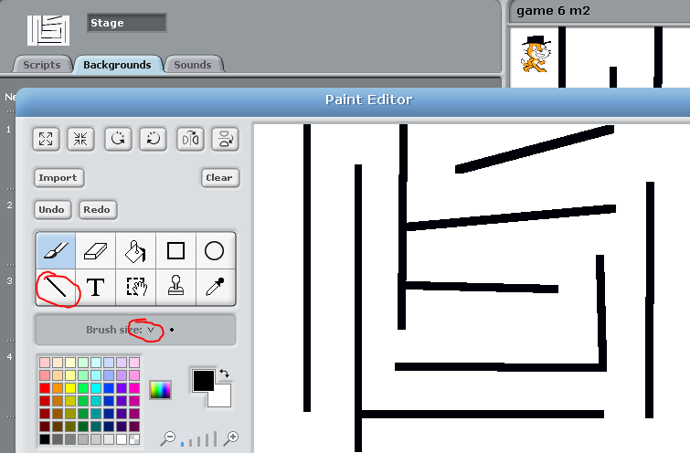

**Step 2: Walking the maze**

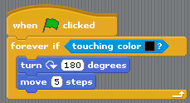Put Scratchie in the top left corner of the maze and take note of his position. Add the following script to cause him to bounce when he touches the maze color:

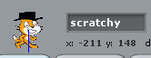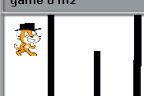

Now add the movement commands, you will need to complete the left/right arrows/. Try running around the maze. Hint: you should not be able to talk through walls!

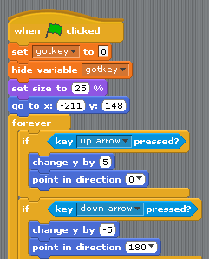

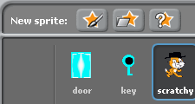**Step 3: Maze goals**

Create a key and a door sprite. Make the door a different color than the maze. The scripts below control the key and door actions:

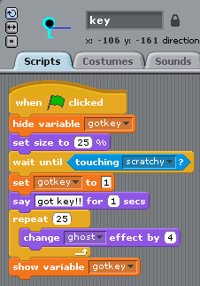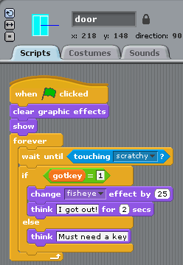

**Step 4: Next steps**

* Add a monster that prowls the maze
* Add some way to score
* Switch to another maze when you get out of the maze

**Final Project**

**Name: ___________________________ (project name, not your name!)**

|  |  |
| --- | --- |
| Project Description   |  | | --- | |  |   The steps I will take to develop my project: |
|  |
|  |

**Sketches of my final project**

|  |  |  |
| --- | --- | --- |
| ::::::::::::Desktop:ScratchScreenSnapz004.jpg |  | ::::::::::::Desktop:ScratchScreenSnapz004.jpg |
| What’s happening?  What are the important elements? |  | What’s happening?  What are the important elements? |
| ::::::::::::Desktop:ScratchScreenSnapz004.jpg |  | ::::::::::::Desktop:ScratchScreenSnapz004.jpg |
|  |  |  |
| What’s happening?  What are the important elements? |  | What’s happening?  What are the important elements? |